Mission Statement
Cleveland County School District
Cleveland County Head Start-ABC Program

THE MISSION OF THE CLEVELAND COUNTY SCHOOL DISTRICT-
CLEVELAND COUNTY HEAD START ABC PROGRAM IS:

To bring a strong awareness on positive family and child outcomes. To close the achievement gap and to build a better future for children, families, and communities served by the Head Start program.
Head Start Performance Standards
The Performance Standards are rules CCHS/ABC Program must go by to keep in compliance with Head Start laws. Volunteers are encouraged to review them.

Target Population
Head Start is primarily for children from low-income families. At least 90% of the children enrolled must meet federal income guidelines, which are updated annually. CCHS/ABC Program provides services to eligible children 3 years old to 5 years old in Cleveland County. The child must be a least 3 years old by August 1st of the year he/she is enrolled. The program’s over- income slots are selected through criteria that is entered into an online tracking system called (COPA) and given points by criteria such as disabilities, age, etc.

Agency Structure
CCHS is a federally funded program. The program is administered by the Cleveland County School District, an Executive Director and a governing Policy Council.

The Head Start Policy Council is composed of thirteen (13) members. Ten (10) are parents of currently enrolled Head Start children, and three (3) community representatives who have demonstrated an interest in services provided to low-income children and families. The Policy Council has general responsibility for establishing a method of hearing and resolving complaints about the Head Start program, operating responsibility for conducting program evaluation, and approval/disapproval responsibilities before major decisions are finalized or action is taken.

The Program Director is responsible for supervision of the staff at their local center. The local program staff includes Classroom Teachers and Teacher Assistants whose primary duties consist of nurturing and teaching preschool children through organized activities that stimulate each child’s physical, emotional, intellectual and social growth.

Committees
Parents serve on the different committees to join with Head Start staff in making decisions about content and operations of the program, and how they and their children will participate in them. Parents and staff work together to help assess the agency to find strengths and weaknesses of the program. Each center committee is made of a chairperson, co-chair and secretary. The following is a list of committees:

Center Parent Committee
Policy Council
Education Committee
Health Advisory
Community Partnership

Agency Funding
Head Start is a federally funded program that requires a 20% community match (in-kind).The in-kind or non-federal share is raised through volunteer services, donation of equipment or supplies, and donated space, etc. The nutrition program for the children is primarily paid for through the federally funded (USDA), state operated Child Care Food Program.
Services
Head Start is a comprehensive developmental program designed to meet the needs of children from low-income families. Many of those needs can and are met through the component areas. Those components include: Education and Disabilities Services, Family Services, Health and Nutritional Services, Community Partnerships, and Literacy. All services provided for the child and the families are of equal importance depending on the needs of the child and family.

Definition of a Volunteer
According to Head Start performance standard “Volunteer” means an unpaid person who is trained to assist in ongoing program activities under the supervision of a staff person in areas such as health, education, transportation, nutrition and management.

Volunteer Requirements
Age and Health:
In accordance with Arkansas State Licensing Requirement 304, all volunteers shall be 18 years old or older, unless the volunteer is under the direct supervision of the person in charge and has been approved on an individual basis by the Child Care Licensing Unit.

All regular volunteers will be required to provide evidence of having completed a TB test. If you are a regular Volunteer you will be required to complete the paperwork for child maltreatment Central Registry Check.

Orientation
All volunteers are encouraged to attend an orientation. During this orientation, the person in charge will review key points of information, and the volunteer will be required to acknowledge this training by sign in log.

Volunteer Training
Volunteers are not required to have any special education, training, or skills. If a volunteer has any special talents we encourage them to utilize them in any way possible. In accordance with performance standards, volunteers will be given the opportunity and encouraged to attend trainings and workshops.

Volunteer Standards of Conduct
Volunteers will:
- Respect and promote the unique identity of each child and family and refrain from stereotyping on the basis of gender, race, ethnicity, culture, religion, or disability.
- Follow program confidentiality policies concerning information about children, families, and other staff members.
- Not leave a child alone or unsupervised while under their care
- Use positive methods of child guidance and will not engage in corporal punishment, emotional or physical abuse, or humiliation.
- Not employ methods of discipline that involve isolation, the use of food as punishment or reward, or the denial of basic needs.
- Not solicit or accept personal gratuities, favors, or anything of significant monetary value from contractors of potential contractors.
- Cell phone use is prohibited in the building and around students unless prior approval is given by Center Director for emergency situations only! This includes texting and calling. Please refrain from all use!

Volunteer Bill of Rights
Every Volunteer has:
- The right to be treated as a co-worker
- The right to a suitable assignment
- The right to know as much about the organization as possible
- The right to training for the job
- The right to continuing job education
- The right to sound guidance and direction
- The right to have a place to work
- The right to promotion and a variety of experiences
- The right to be heard
- The right to be recognized

Volunteer Job Descriptions
CCHS maintains a list of available volunteer job descriptions. All volunteers are encouraged to investigate opportunities within the program at any time, and we invite your ideas for new work opportunities.

Activities
- Comfort or make children feel wanted at the center as they come in.
- Read stories to the children
- Help children with puzzles or other games they can work with.
- Help with finger paints and other art materials.
- Play games with children; also teach new songs.
- Help with supervision on playground.
- Help with supervision on field trips.

Guidance and Discipline Policy
Our positive guidance policy is to begin with an environment, which reinforces positive behavior in children. If a child behaves inappropriately, we will use a number of methods to encourage positive behavior. It is the responsibility of the adult that is supervising the children to help prevent discipline problems by:
- Accepting each child’s worth and importance and understand each child’s behavior is a reflection of their experience to date.
- Anticipating and intervening before disruptive behavior occurs.
- Providing a learning environment that is interesting, challenging, and at the developmental level of the child.
- Being consistent, following the daily schedule every day and have an orderly flow through routines so that a child is neither hurried nor required to spend much time waiting in line.
Having rules that children help develop and make sure children understand the rules. Be firm, fair and consistent. When inappropriate behavior occurs in the center, these steps will be taken:
- Teacher will talk to the child and try to help them find appropriate ways to correct the behavior or solve the problem causing the behavior. For example: “Use your words to tell how you feel. “Hitting is not okay” or “We need to share.” How about I set the timer for 5 minutes and you take turns when you hear the ring?”
- If talking is unsuccessful, the adult will re-direct the child by giving them other acceptable choices. For example: “Since we’ve talked and can’t solve the problem, you can go to another center to play.”
- If the previous steps have not changed the behavior, the child will be placed in a “time-out” chair where they are instructed to sit, relax and calm themselves for one minute per year of age (3 year olds sit “quietly for 3 minutes). An adult will supervise the child at all times. The adult explains to the child the reason they are being placed in “time-out.”

The maximum time spent in time-out coincides with their age, but does not begin until the child is calm. If the child refuses to go to time-out, or their behavior is very disruptive to other children, the child may be carried away from the group (out of the classroom) and held by an adult until his/her behavior is appropriate. It is the responsibility of the teacher (adult responsible for supervision of children) to ensure that discipline shall not be associated with food, rest, toilet training or isolation for illness. Physical punishment shall not be administered to children. The following activities are forms of punishment, not discipline, and are not to be used for children. These include, but are not limited to: restraints, harsh treatment, washing mouth out with soap, verbal or abusive language, isolation without supervision, hitting , pinching, pulling hair, slapping, swatting, spanking, etc.

Reporting Child Abuse & Neglect
It is the responsibility of everyone at Head Start to help keep children safe. Sometimes you may suspect that a child has been abused or neglected. Sometimes children will tell teachers, other staff members and other adults that they have been abused.
Arkansas law requires that any individual working in a licensed childcare facility that suspects a child has been abused or neglected MUST REPORT to the proper authorities. CCHS/ABC staff and volunteers are required to obey that law by reporting suspected incidences of abuse or neglect. All reports are kept confidential.

The Arkansas Child Abuse Hotline is available 24 hours per day, 7 days per week, 365 days per year to take your call. The phone number is 1-800-482-5964.

Emergency and First Aid Procedures
Each center has a plan for emergency procedures and a plan for emergency situations that require first aid. The center director will provide you with clear rules about universal precautions and first aid treatment. Maps of evacuations are posted in each classroom. The center director and classroom staff will identify this information for you, but it is the responsibility of volunteers to familiarize themselves with these routes. Volunteers will be given the opportunity to receive CPR and First Aid training with CCHS/ABC staff; however, volunteers should not practice first aid treatment unless program staff is not able. Regular fire, tornado, vehicle evacuation or emergency drills will be conducted and everyone is responsible for knowing his/her role in case of an emergency.

Transportation
Seat belts must be worn at all times by everyone in the vehicle. Vehicles must be checked using the established procedures. Eating and drinking are not permitted while transporting children.

Personal Appearance/Hygiene
All volunteers are expected to adhere to the dress code suitable for your school district. Volunteers are expected to wear clothing that will reflect pride in the center as well as setting a good example of dress and grooming for the children. Dress in comfortable, well-fitting clothes that will allow you to join in the children’s activities.

Confidentiality
All volunteers are expected to adhere to the Cleveland County School/Cleveland County Head Start confidentiality policy. Specifically, child records, family records and employee records are confidential information

Tobacco Use
Volunteers are expected to adhere to the CCHS personnel policy with regards to smoking. No smoking is permitted at any time on program premises (including the building, the parking lot, sidewalks, etc.) in program vehicles, or at any time the volunteer is representing the program. Head Start Bureau final program instruction effective 05/01/95 requires all Head Start programs to provide a smoke-free environment for children and adults who participate in the program.

Meal Periods
Head Start Performance Standards states that staff (paid or unpaid) must ensure that nutritional services in the center-based settings contribute to the development and socialization of the enrolled child. All children, classroom staff, including volunteers, must eat together family style and share the same menu to the extent possible.
Adults are to eat with the children at every meal, including snack. Adults should be at the table with the children. Adults are to eat what the children eat, with no exceptions. If an adult cannot eat something on the menu, a signed statement from a doctor/religious clergy is required just as it is for a child at the center. If an adult wants to eat or drink something on a break, he/she shall not eat or drink it in front of the children. It must be consumed in a break area or outside the building.
Children are to be encouraged to taste all foods, but never forced. The right of a child to refuse a food is to be respected. Food must never be used as a punishment or reward. A child will never be deprived of a meal or snack for any reason. This practice is a licensing requirement (500 Behavior Guidance #5L). Children need to participate in meal service. They can wipe tables, set tables, help serve food, wipe up spills and clean up.
Mealtime should be a relaxed atmosphere. Make conversation with the children and do not rush to finish. Allow slow eaters at least 30 minutes to finish. Basic table manners are to be practiced at every meal.
Everyone, adults as well as children, need to wash their hands before eating. If food is dropped on the floor, throw it away. If silverware is dropped on the floor, get a clean replacement. This practice is a licensing regulation (700 Nutrition #4 &1102 Hand Washing #4).

Center Locations

Kingsland Head Start Center
Hwy 79
Kingsland, AR 71652
Phone: 870-348-5778

Rison Head Start Center
700 Main Street
Rison, AR 71665
Phone: 870-325-6306
870-325-6309
870-325-6324

Woodlawn Head Start Center
6760 Hwy 63
Rison, AR 71665
Phone: 870-357-2579

Table of Contents

Program Mission Statement
Head Start Performance Standards
Target Population
Agency Structure
Committees
Agency Funding
Services
Definition of a Volunteer
Volunteer Requirements
Orientation
Volunteer Training
Volunteer Standards of Conduct
Volunteer Bill of Rights
Volunteer Job Descriptions
Activities
Guidance and Discipline Policy
Reporting Child Abuse & Neglect
Emergency and First Aid Procedures
Transportation
Personal Appearance/Hygiene
Confidentiality
Tobacco Use
Meal Periods
Center Locations
Cell Phone Use

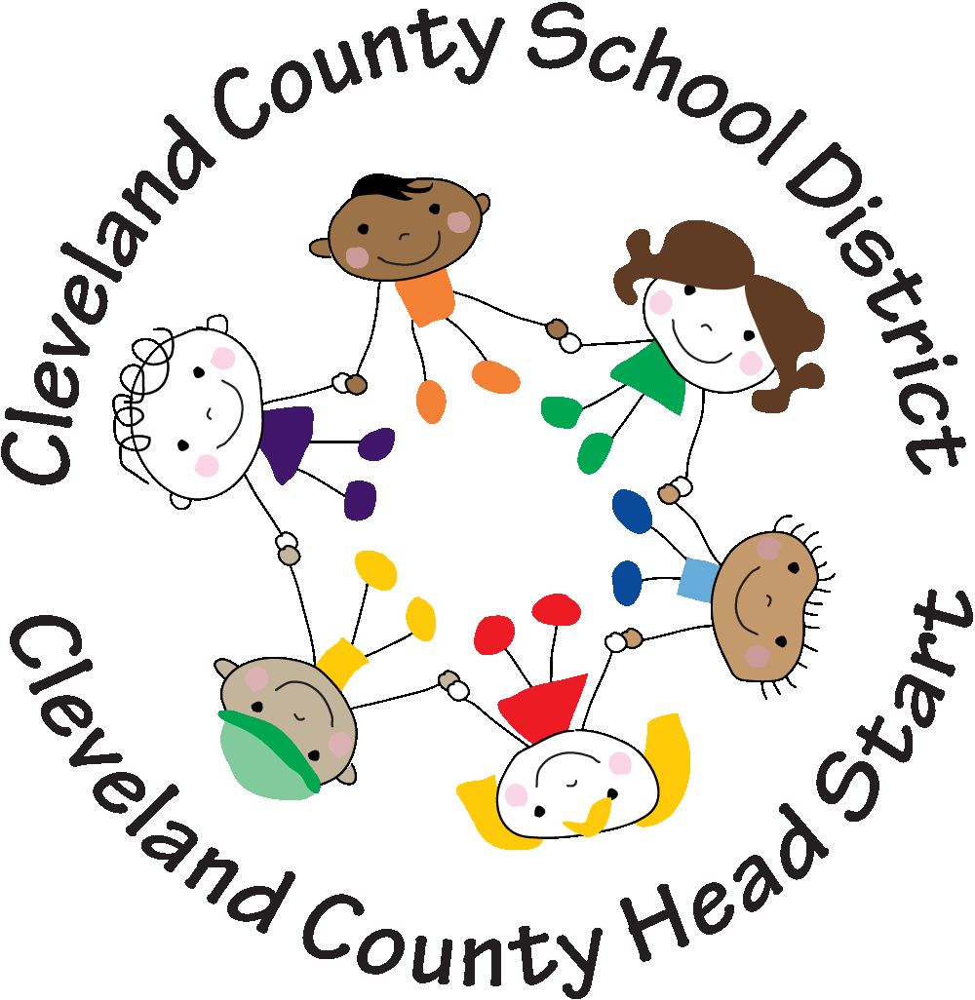

Volunteer Handbook
2013-2014

Cleveland County School District
Cleveland County Head Start
ABC Program

